Using Ausfarm-Stock in APSIMUI
J.N.G. Hargreaves
05 Feb 2008

Summary

Introduction
The Ausfarm-Stock (Stock) component is used in APSIM to graze APSIM-Plant derived crops, such as Lucerne, Lablab and Wheat. The Ausfarm-Supplement (Supplement) component can also be used as a supplementary feed source for stock. Management operations can be carried out such as buying and selling of stock, supplementary feeding and moving stock to another paddock. Currently the paddock sizes are fixed at one hectare.

To use Stock in an APSIM simulation, three companion APSIMUI components are required – StockScienceConverter, StockHerbageConverter and FarmwiseSequencer.
e.g.
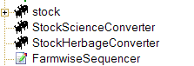

When Supplement is used, its companion SupplementScienceConverter is also required.
e.g.
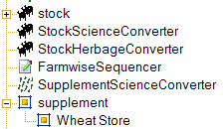

All of these components are found in the APSIMUI Standard Toolbox in the Animals Folder. E.g.
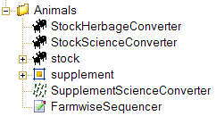

A sample simulation (Wether_Lucerne_Supplement) of grazing wethers on lucerne with supplementary feeding of wheat is provided under the New menu.

APSIMUI components

Stock
The Stock component initialises with default properties and no animals.

StockScienceConverter
The StockScienceConverter initialises with the values specified in its properties grid e.g.

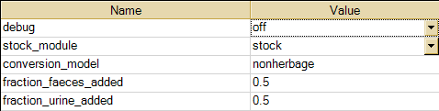

- Debug
- Stock_module
- Conversion_model
- Fraction_faeces_added
- Fraction_urine_added

StockHerbageConverter
The StockHerbageConverter initialises with the values specified in its properties grid. E.g.

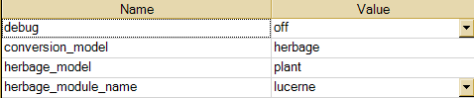

  - Debug
  - Conversion_model
  - Herbage_model
  - Herbage_module_name

FarmwiseSequencer
The FarmwiseSequencer initialises with properties specified in its INI file. These properties translate APSIM events to Ausfarm events and should only be altered after consultation with the SEG.

Supplement
Supplement initialises with the values specified in its properties grid.

  - Spoilage_time

- Supplement Store
The supplement store properties define the initial values of each supplement being used in the simulation.

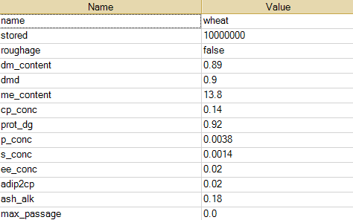

SupplementScienceConverter
The SupplementScienceConverter initialises with values specified in its properties grid. E.g.

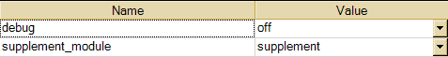

  - Debug
  - Supplement_module

Management
Pre-defined management rules of stock (cattle and sheep) and supplement feeding are found in the Stock folder under the Management folder in the Standard Toolbox.
E.g.

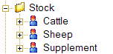

Pre-defined cattle management rules for buying, selling and moving stock.

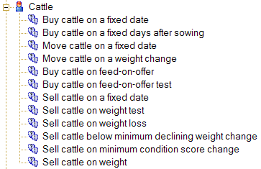

Pre-defined sheep management rules for buying and selling stock.

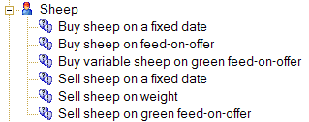

Pre-defined supplement management rules for buying, mixing and feeding stock.

